**STOCK PRICE PREDICTION**

**WITH MACHINE LEARNING**

**PHASE:05. Project documentation**

STOCK PRICE PREDICTION :

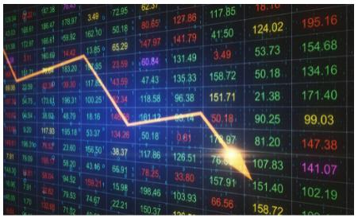 A stock market is a public market where you can buy and sell shares for publicly listed companies. The stocks, also known as equities, represent ownership in the company. The stock exchange is the mediator that allows the buying and selling of shares.

OBJECTIVES:

Stock Price Prediction using machine learning helps you discover the future value of company stock and other financial assets traded on an exchange. The entire idea of predicting stock prices is to gain significant profits. Predicting how the stock market will perform is a hard task to do. There are other factors involved in the prediction, such as physical and psychological factors, rational and irrational behavior, and so on.

All these factors combine to make share prices dynamic and volatile. This makes it very difficult to predict stock prices with high accuracy.

DESIGN THINKING PROCESS:

Applying design thinking to stock price prediction involves a user-centered approach to creating tools or systems that assist investors or traders. Here’s how the design thinking process can be adapted for this purpose:

* Empathize: Understand the needs and challenges of investors and traders. Conduct interviews and gather data on their decision-making processes, information sources, and pain points.
* Define: Clearly define the problem statement, such as “How might we provide more accurate and user-friendly stock price predictions for investors?”
* Ideate: Brainstorm potential solutions that cater to the defined problem. This may involve considering various data sources, algorithms, and visualization methods.
* Prototype: Create low-fidelity prototypes of the stock prediction system or tool. This could include sample interfaces or models of how predictions might be presented.
* Test: Engage with users (investors and traders) to test the prototypes. Gather feedback on the usability, accuracy, and usefulness of the predictions.I
* Implement: Based on user feedback, refine the stock prediction system or tool. Develop the actual software or platform and continuously iterate based on real-world usage and feedback.

Throughout this process, it’s essential to keep user needs and feedback at the center, and to collaborate with experts in data science and finance to ensure the accuracy and reliability of the predictions. Design thinking can help create stock prediction solutions that are not only data-driven but also user-friendly and aligned with the specific needs of the financial industry.

PHASE OF DEVELOPMENT:

The development of a stock price prediction model typically goes through several phases:

* Data Collection: Gather historical stock price data, financial reports, news sentiment data, and other relevant information. The quality and quantity of data are crucial for building an accurate model.
* Data Preprocessing: Clean and prepare the data. This involves handling missing values, scaling, and normalizing data, and creating features that might be useful for prediction
* Feature Selection/Engineering: Identify the most relevant features for the prediction model. This might involve creating new features based on domain knowledge.
* Model Selection: Choose an appropriate machine learning or statistical model for stock price prediction. Common models include regression, time series analysis, and more advanced techniques like neural networks.
* Training: Train the selected model on historical data. This involves splitting the data into training and testing sets and using the training set to teach the model.
* **Hyperparameter Tuning:** Fine-tune the model's hyperparameters to optimize its performance.
* **Validation:** Evaluate the model's performance using the testing data. Common metrics include Mean Absolute Error (MAE), Mean Squared Error (MSE), and Root Mean Squared Error (RMSE).
* Backtesting: Apply the model to historical data to see how well it would have performed in the past. This step helps assess the model’s practicality.
* Deployment: Implement the model into a trading system or platform if it proves to be accurate and reliable.
* Monitoring and Maintenance: Continuously monitor the model’s performance and update it as needed. Financial markets are dynamic, and models may require regular recalibration
* Risk Management: Develop risk management strategies to mitigate the potential consequences of incorrect predictions.

DATASET USED:

Stock price prediction models rely on various datasets to make forecasts. Some of the key data sources used in stock price prediction include:

* Historical Stock Prices: Time-series data of a stock’s historical prices, including daily, weekly, or hourly open, close, high, and low prices. This data is essential for training and testing prediction models.
* Volume and Liquidity Data: Trading volume and liquidity indicators provide insights into market activity and can be important factors in stock price movements.
* Financial Statements: Fundamental data from a company’s financial reports, including balance sheets, income statements, and cash flow statements. Ratios like price-to-earnings (P/E) and earnings per share (EPS) are often used.
* News and Sentiment Data: Information from news articles, social media, and other sources can impact stock prices. Sentiment analysis can be used to gauge market sentiment based on news and social media content.
* Economic Indicators: Economic data such as GDP growth, inflation rates, and interest
* rates can influence overall market trends and individual stock performance
* Market Index Data: Data from broader market indices like the S&P 500 can be used to understand the overall market’s performance, which can impact individual stocks.
* Technical Indicators: Indicators like moving averages, Relative Strength Index (RSI), and Bollinger Bands can provide insights into historical price trends and potential future movements.
* Alternative Data: Unique data sources such as satellite imagery, credit card transactions, or supply chain data can be used to gain insights into a company’s performance or the broader market.

DATASET USED SAMPLE:

ANALYSIS OBJECTIVES: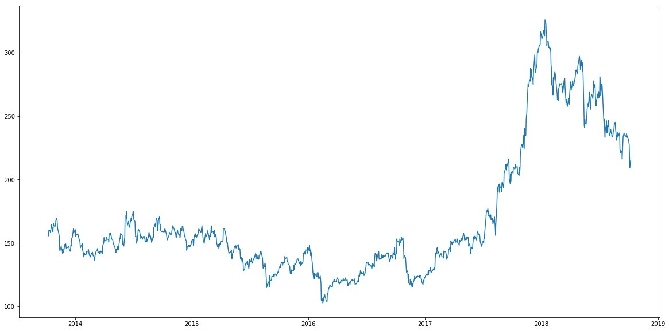

* Short-Term Price Prediction: Determine the stock’s expected price over the next few minutes, hours, or days. This is useful for day traders and high-frequency trading strategies.
* Medium-Term Price Prediction: Forecast the stock’s performance over weeks or months, aiming to identify trends and potential investment opportunities for swing traders and investors.
* Long-Term Price Prediction: Estimate the stock’s future price over several years, assisting long-term investors in making buy-and-hold decisions.
* Volatility Prediction: Analyze and predict the stock’s price volatility, which is essential for options traders and risk management.
* Trend Analysis: Identify and quantify trends in the stock’s historical price data to assist in trend-following strategies.
* Pattern Recognition: Recognize and predict technical chart patterns, such as head and shoulders, double tops, or flags, which can be used in technical analysis.
* Event-Based Analysis: Evaluate the impact of specific events (e.g., earnings reports, product launches, geopolitical developments) on a stock’s price.
* Sentiment Analysis: Assess market sentiment by analyzing news, social media, and other sentiment indicators to gauge how they influence stock prices.

DATA COLLECTION PROCESS:

The data collection process in stock price prediction involves gathering and organizing various types of data that will be used to train and test prediction models. Here are the key steps in the data collection process:

* Identify Data Sources: Determine the sources of data that are relevant to stock price prediction. Common sources include financial markets, news outlets, company financial reports, and alternative data providers.
* Historical Price Data: Collect historical stock price data, including open, high, low, close (OHLC) prices, and trading volumes. This data is essential for time-series analysis and model training.
* Fundamental Data: Gather data from financial statements, such as balance sheets, income statements, and cash flow statements. This information includes metrics like earnings per share (EPS), price-to-earnings (P/E) ratios, and dividend yields.
* News and Sentiment Data: Acquire news articles, social media content, and sentiment analysis data related to the stocks of interest. News sentiment can impact stock prices.
* **Economic and Market Data:** Collect macroeconomic data such as GDP growth, inflation rates, and interest rates. Also, obtain data on broader market indices and industry-specific indices.
* **Technical Indicators:** Obtain data on technical indicators like moving averages, Relative Strength Index (RSI), and Bollinger Bands. These indicators can help identify trends and trading signals.
* Alternative Data: Explore unique data sources like satellite imagery, supply chain data, and credit card transaction data to gain insights into a company’s performance or industry trends.
* Options and Derivatives Data: Include data related to options and derivatives trading, which can offer insights into market sentiment and expectations.
* **Corporate Events Data:** Gather information on corporate events like earnings releases, product launches, mergers and acquisitions, and other events that can impact stock prices.
* **Social Media Data:** Collect data on social media trends, mentions, and discussions related to specific stocks to gauge market sentiment.

